**Create Node-RED Service**

|  |  |
| --- | --- |
|  |  |
| **Team ID** | **PNT2022TMID50776** |
| **Project Name** | **IOT based safety gadget for**  **child safety monitoring and notification** |
| **Maximum Marks** | **4 Marks** |
|  |  |

Aim: To create a web applications create a Node-RED service. Steps followed:

* 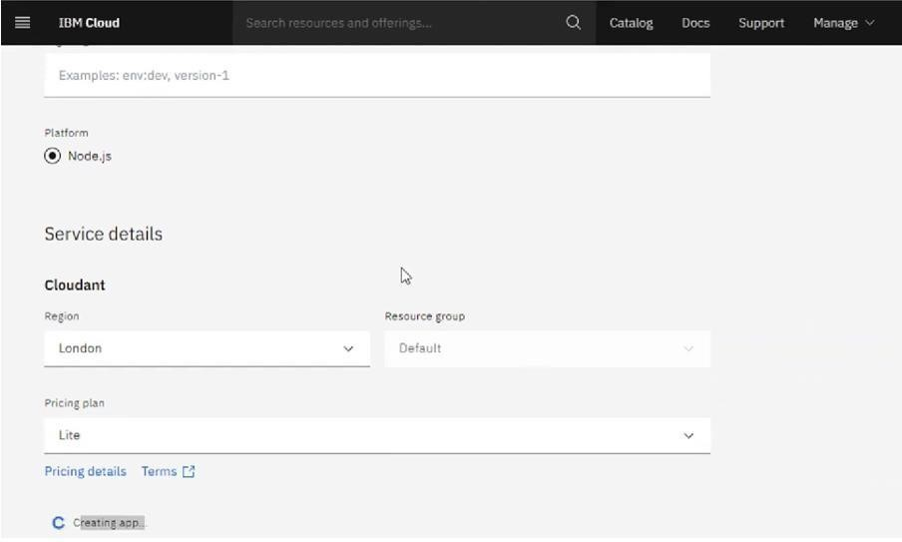Navigated to the App creation page

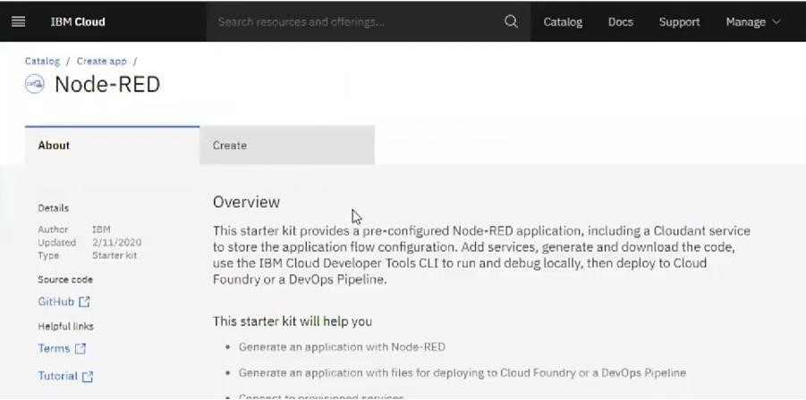

* Entered project details and clicked on create

* Clicking on the “Deploy your App” Button

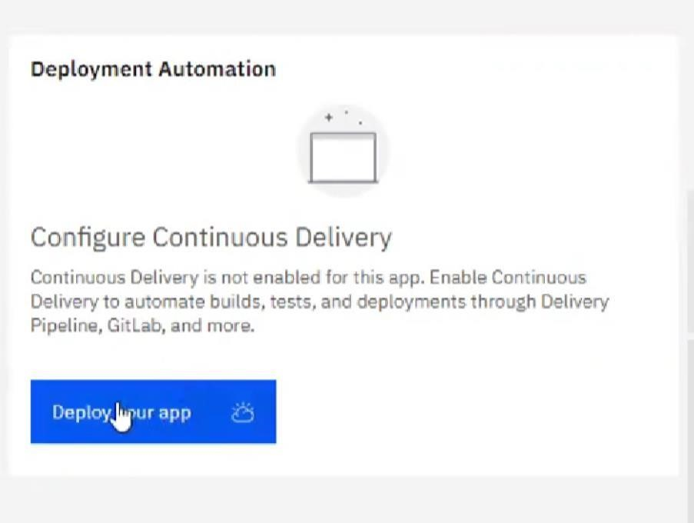

* Setting up the environment and deploying the app

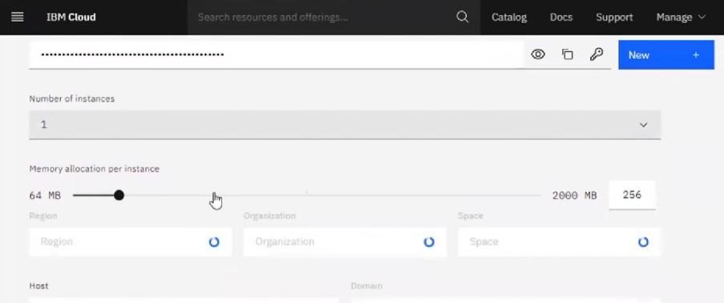

* Successfully deployed the app

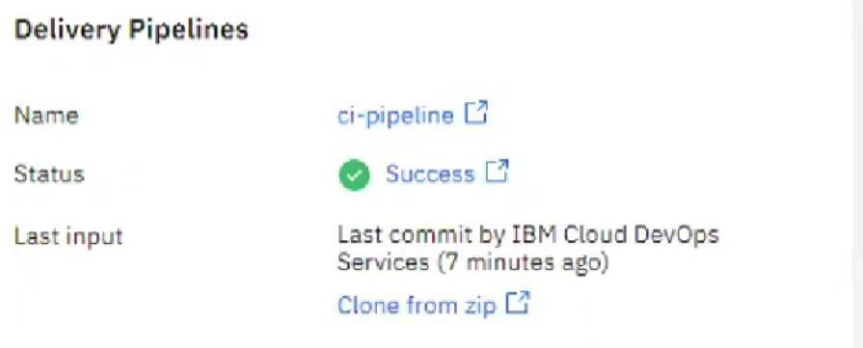

* Dragged and dropped components into the editor

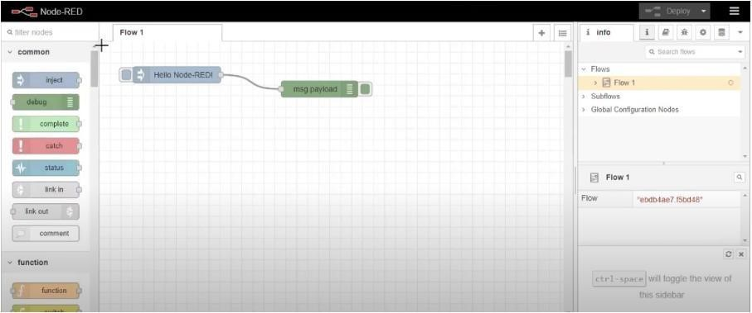

* Editing some values of the properties

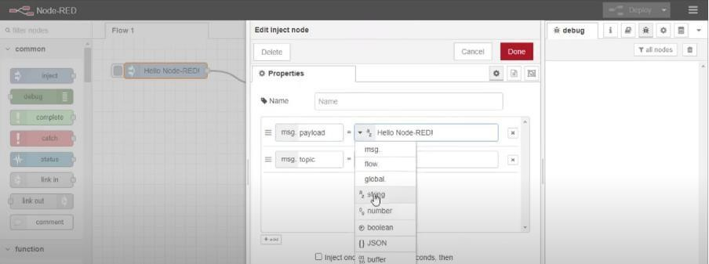

* Successfully deployed the app

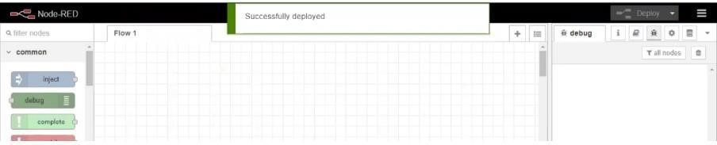

# Result: Successfully created a NodeRED service on IBM Cloud